

**HOW TO SET UP YOUR ACCOUNT ON THE APP**

1. Download the App from your app store
2. Enter your email address
3. Select Continue
4. Select Forgot Password
5. Go to your email account and open the email from Mindbody
6. Use the link to set your password
7. Create your password and log in to the app
8. Select the Search menu

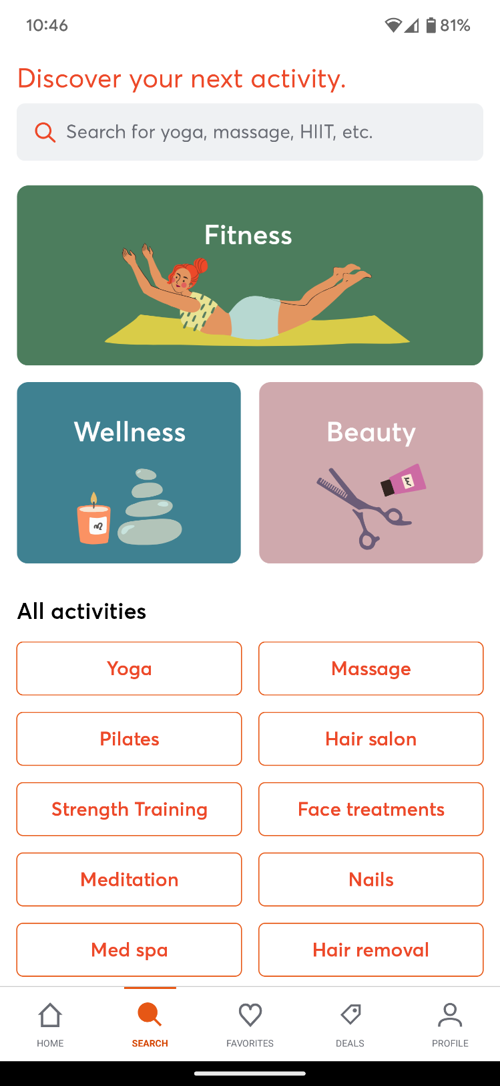

1. In the Search field, enter Brighton Rec Centre
2. Make sure to save Brighton Rec as a Favourite

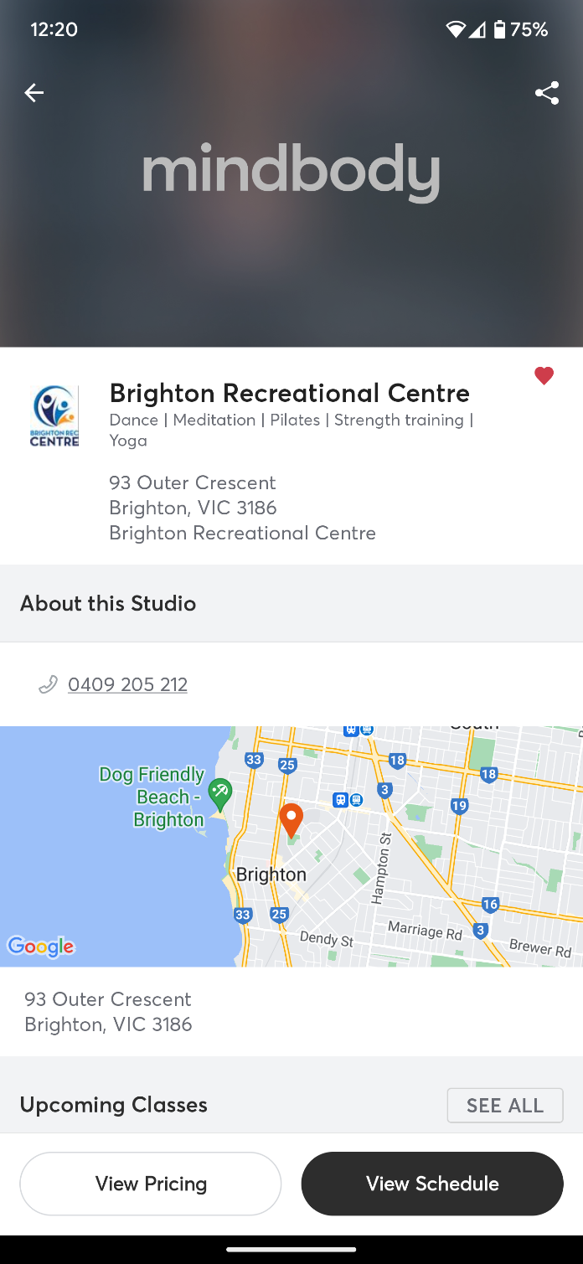

1. You are now all set to book into classes

**HOW TO BOOK A FITNESS AND WELLNESS CLASS**

1. Open your Mindbody app and log in
2. From the Home page, select Brighton Rec Centre
3. Use the calendar (top right) to select the day you are wanting to book a class, or slide across the week to see the next week. Remember you can only book up to 7 days in advance.

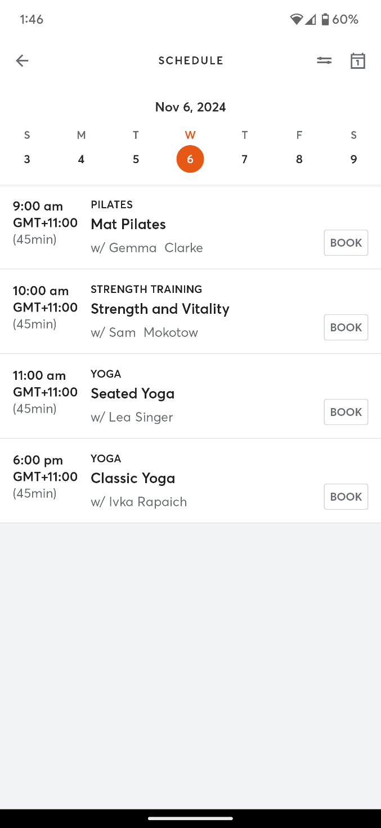

1. Find the class you are after and select BOOK
2. Review the booking details and select BOOK to finalise the booking.

**HOW TO CANCEL A BOOKING**

1. Open your Mindbody app and log in
2. Select your Profile tab

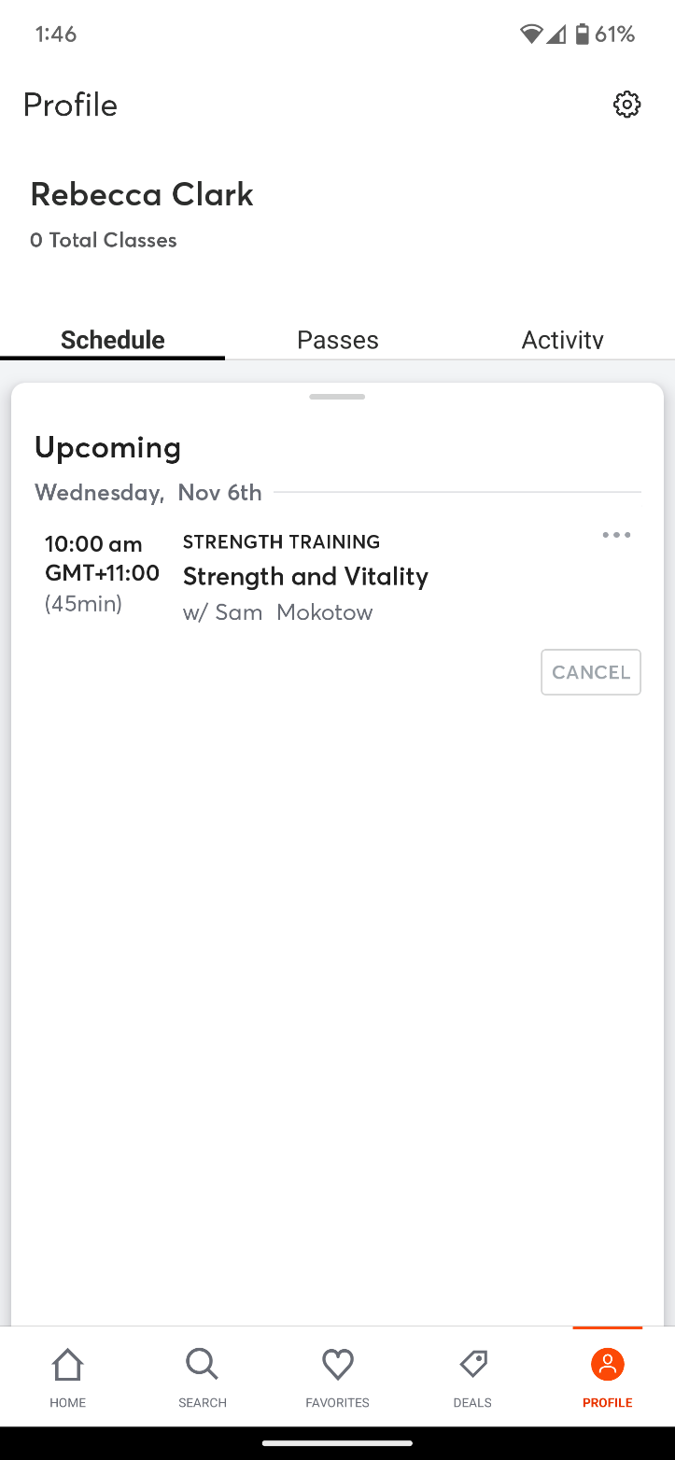

1. Find the class you need to cancel and select Cancel

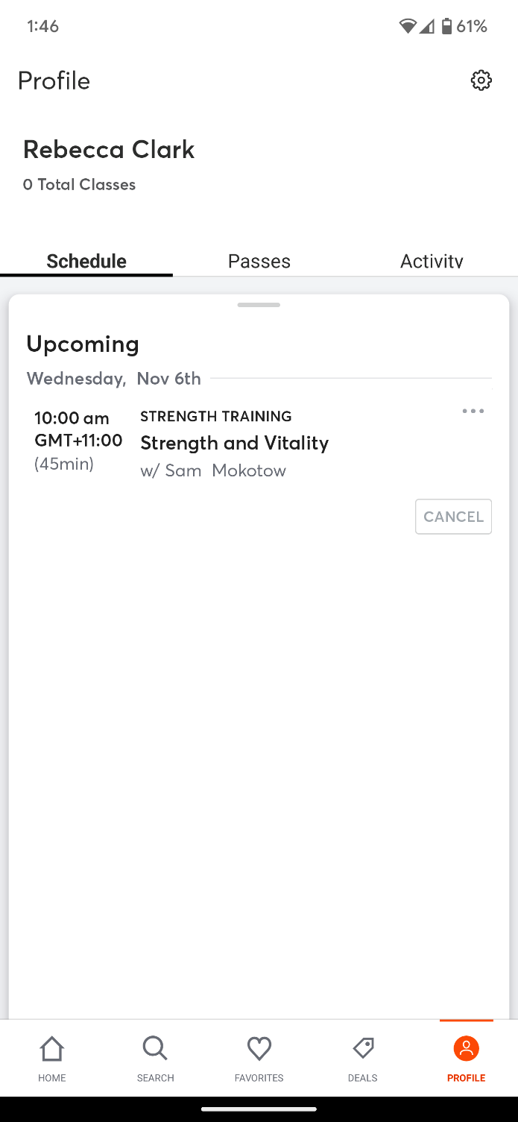

1. Confirm you want to cancel the booking